**NEED SPONSOR**

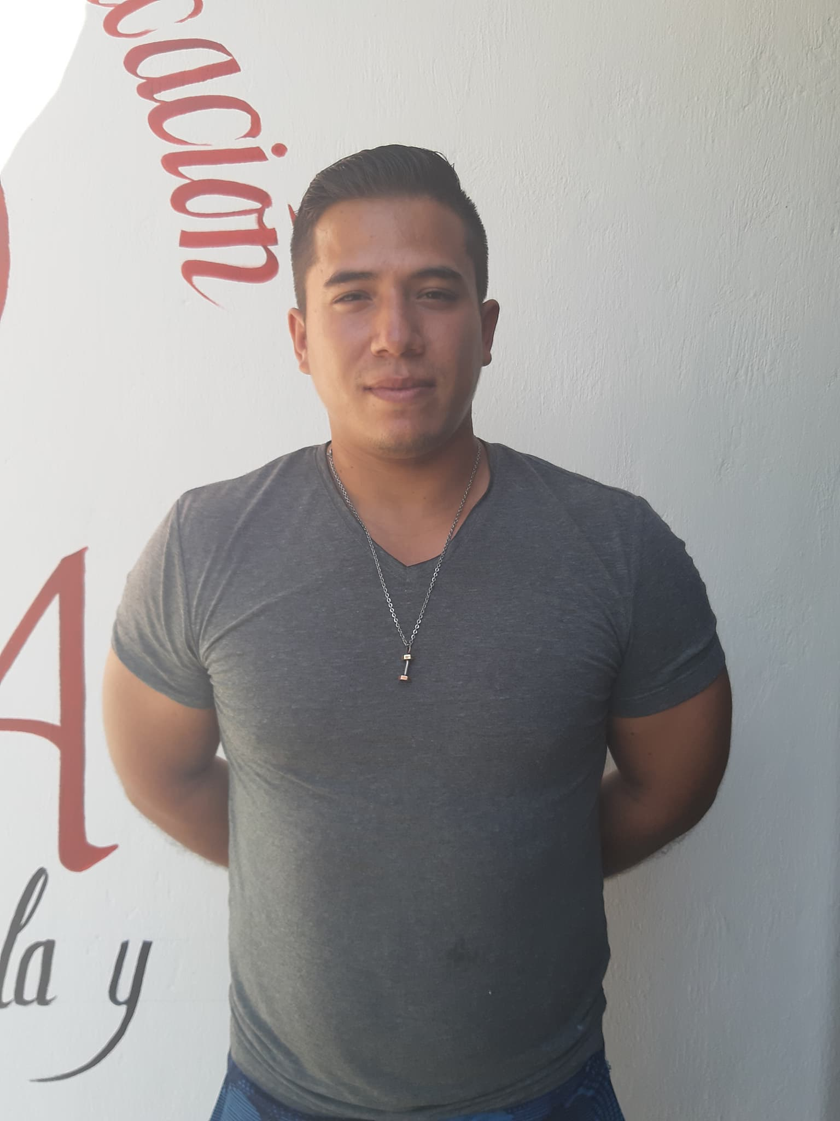

**Name: Carlos Daniel Zuñiga Farias**

**DOB:** 24/September/1992

**AGE:** 27 years old.

**GPA:** 88.0

**Location:** Chapala

**School:** Une Centro Universitario

**Current Level:** 3st Semester 2019 Feb-July.

**Next Level**: 4th Semester 2019 Ago-Dec.

**Carlos**

**He would like to be a Dentist.**

**Carlos** likes to go to school and his favorite subject at school is life pathology and his least favorite is patient management. He has skills for learn and memorizes. He has few friends. He gets along well with his friends and with his family. He has a friendly personality. He has a part time job to help with the house expenses. His favorite sport is soccer. His favorite hobby is go the gym. He would like to be a dentist.

**Her dad´s** name is Jesus. He has a high school education. He works as a merchant.

**Her mom’s** name is Rosa. She has a high school education. She works as a laboratory technician.

**Home:** Carlos shares his home only with his wife, father and mother in law, brother and sister in law, and niece. Their home has a kitchen, living room and five bedroom with three full beds and two single bed.